Press release Sculpteo
Paris & San Francisco, May 31, 2018

Sculpteo Releases the “State of 3D Printing” 2018
The international annual report that decrypts 3D Printing and helps companies build their 3D printing strategy

- 3D Printing on its way to mass production!
- Costs decrease
- Innovation in materials
- Acceleration
- And more…

Sculpteo, leader in online 3D printing and digital manufacturing, today announces the release of its fourth edition of the “State of 3D Printing”, the international annual report that runs a diagnostic on 3D printing and offers a complete overview of the additive manufacturing world. The view of 3D printing as a competitive advantage is stronger, as investments continue to grow, but the products, the materials and the technology itself will substantially evolve over the upcoming years. 3D Printing is becoming a powerful tool more accessible to businesses and a standard production process, used for the creation of end-use products.

Each year Sculpteo collects data about the additive manufacturing industry to highlight keys trends about this dynamic and rapidly evolving industry. Over 1,000 respondents participated in the study from Europe and the United States, with an increase in women respondents of 4% and an overall decrease of the age segment. Respondents come from diverse industry segments including Industrial Goods (17%), Consumer Goods (12%), Aeronautical and Aerospace Industry (7%), and Healthcare (6%).

The Ever-Growing Market of 3D Printing
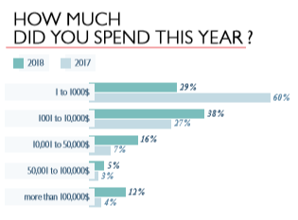
The report shows that 3D printing is a trustworthy manufacturing technique, used by professionals to a greater extent, each year. They are 70% to increase their expenses in 3D printing in 2018, versus 49% the previous year, with 38% of the respondents spending between 1001 and 10,000$ in the technology in 2018 (an 11% increase compared to 2017).

For many businesses, this manufacturing technique has become a reliable and common production or prototyping process: 93% of the companies see it as a competitive advantage and 74% of them note that it is also used by their competitors. The return on investment is stable, showing that professional additive manufacturing users are satisfied with their investments.

The Raise of Metal and a Wider Portfolio of Applications
In 2018, additive manufacturing is now more integrated in the companies’ activities. It is mostly used for R&D, design and production. Among benefits such as the lower costs and the short lead time, most professionals (48%) are using the technology to conceive complex geometries.

We can notice an impressive raise of the use of 3D printing for applications in the production field: 43% of the respondents used additive manufacturing for production purpose in 2018 versus 22% in 2017! This change can be related to a wider use of metal materials, which increased from 28 % in 2017 to 36 % in 2018. The use of the Direct Metal Laser Sintering technology has also seen a significant increase: from 21 % of our respondents are using this metal 3D printing technology, and it keeps increasing.

In-house Machines Leading to Higher Expertise
Professional 3D printing services are commonly used by businesses to get access to other additive manufacturing technologies than the ones they own in-house, as more companies purchase 3D printers. Their number increased by 22 %. Last year, 53 % didn’t even own one, and only 28 % owned two or more.
As businesses purchase more 3D printers, higher technical skills are required to boost performance. They are nearly half to label themselves as experts in additive manufacturing this year, versus 20% last year. The trend is set to continue.

Multiple Key Benefits for Companies
Accelerating product development clearly is the top priority of our respondents (39 %) and it increases as competition between companies becomes more intense. Professionals also want to offer customized products and limited series (25 %), and to increase production flexibility (19 %). More than one priority has often been quoted, showing that 3D printing can have multiple key benefits for businesses. Additive manufacturing becomes more central in business strategies.

To fully capitalize on 3D printing, companies will seek to increase the expertise and the education of their collaborators. Indeed, the lack of education in additive manufacturing technologies is often what blocks companies in their use of 3D printing. Changing the company’s culture and organization is also quoted.

How to Differentiate?
In the long run, there are three main ways to differentiate: product or service quality (30 %), innovation speed (29 %), and product/ service choice and customization (21 %). These three options are totally compatible with 3D printing, a technology which helps build better products, innovate faster, and enables mass-customization. Compared to last year, companies tend to focus more on innovating faster than on offering a wider range of products. When it comes to 3D printing activities themselves, machine capabilities (68 %) and material supply and cost (66 %) appear to be the most important factors, showing the importance of innovation in 3D printing technologies and materials. There is a growing importance of material supply and cost, and the demand for innovation in terms of materials and technologies keeps increasing.

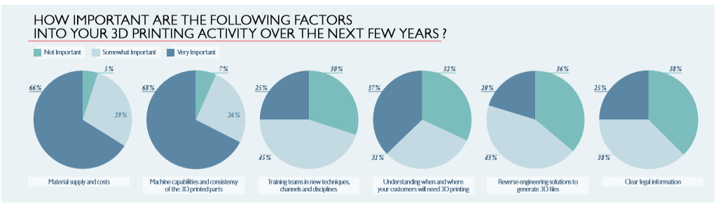
Access the full survey: https://www.sculpteo.com/en/get/report/state_of_3D_printing_2018/

About Sculpteo
Sculpteo, pioneer and specialist of digital manufacturing, offers a service of online 3D printing, from 3D model transfer to the order of the object, and wants to make this technology easy and accessible to all. Based in San Francisco and Paris, Sculpteo offers on-demand 3D printing and manufacturing in large scale for start-ups, SMEs and design studios. The offer of Sculpteo resembles more than 100 combinations of materials with multiple colors and finishing options, as well as a technical analysis and superior repair of files. The Sculpteo factories use professional 3D printers and laser cutters with a very fast execution and a global delivery. Sculpteo was created in 2009 by Eric Carreel and Clément Moreau.

For more information: www.sculpteo.com

Press Contacts:
Jean-François Kitten: jfk@sculpteo.com +33(0)6 11 29 30 28
Ilinca Spita: i.spita@licencek.com +33(0)9 72 33 47 63
Badr Rar: b.rar@licencek.com +33(0)9 72 33 47 63

